Task 6: Create a Strong Password and Evaluate Its Strength
Date: 28-10-2025
Jyotsna Bansode

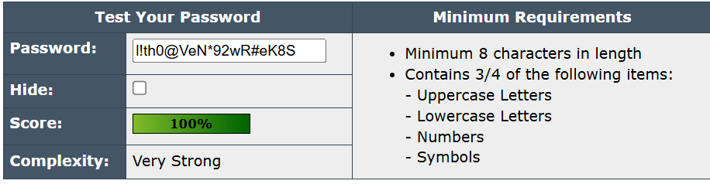
Strength Analysis
- Length: 20 characters → excellent for security
- Character variety: Includes uppercase, lowercase, numbers, and symbols
- Predictability: No dictionary words or common patterns
- Resistance: Extremely difficult to crack with brute-force or dictionary attacks
Overall, it is highly secure and suitable for protecting sensitive accounts.

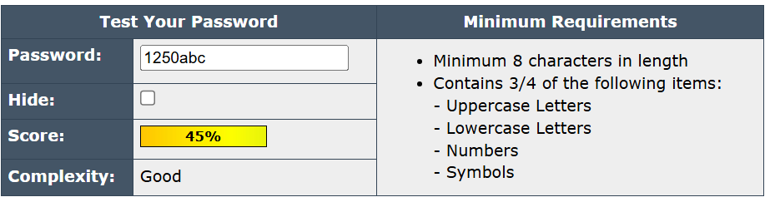

Strength Analysis
- Length: Only 7 characters → too short for strong security
- Character variety: Contains only numbers and lowercase letters → minimal complexity
- Predictability: Uses a common sequence (abc) → easily guessed
- Resistance: Vulnerable to brute-force and dictionary attacks
Overall, it is not secure and should be replaced with a longer, more complex password.

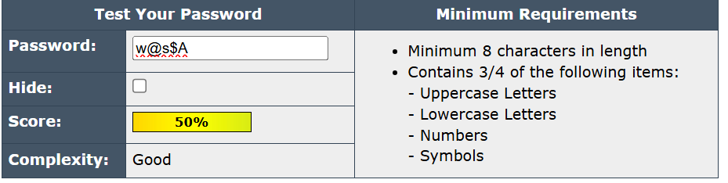

Strength Analysis
- Length: Only 5 characters → far too short
- Character variety: Some symbols and uppercase, but overall minimal complexity
- Predictability: Very short, easy to guess or brute-force
- Resistance: Extremely vulnerable to attacks
Overall, it is not secure at all and should be replaced with a longer, more complex password.

Summary
Among the passwords entered, l!th0@VeN*92wR#eK8S is very strong due to its long length, mix of uppercase and lowercase letters, numbers, and symbols, making it highly secure against attacks.
The password 1250abc is weak because it is short, contains predictable sequences, and uses common characters, making it vulnerable to brute-force and dictionary attacks.
The password w@s$A is very weak due to its extremely short length and minimal complexity, providing very little security. Overall, longer passwords with diverse characters are much stronger and more resistant to attacks.

